Date: 31/03/26
📊 Final Count:
🟢 Bullish | 3
🔴 Bearish | 97
Total | 100

🟢 BULLISH TRADES --- 3
1 | ASTRAL26AprFUT
2 | DMART26AprFUT
3 | ONGC26AprFUT
🔴 BEARISH TRADES --- 97
1 | 360ONE26AprFUT
2 | ABB26AprFUT
3 | APLAPOLLO26AprFUT
4 | ADANIENSOL26AprFUT
5 | ADANIENT26AprFUT
6 | ADANIGREEN26AprFUT
7 | ADANIPORTS26AprFUT
8 | ABCAPITAL26AprFUT
9 | ALKEM26AprFUT
10 | AMBER26AprFUT
11 | AMBUJACEM26AprFUT
12 | ANGELONE26AprFUT
13 | ASHOKLEY26AprFUT
14 | BSE26AprFUT
15 | BAJAJ-AUTO26AprFUT
16 | BAJFINANCE26AprFUT
17 | BAJAJFINSV26AprFUT
18 | BANDHANBNK26AprFUT
19 | BANKINDIA26AprFUT
20 | BEL26AprFUT
21 | BHARATFORG26AprFUT
22 | BHEL26AprFUT
23 | BIOCON26AprFUT
24 | BLUESTARCO26AprFUT
25 | BOSCHLTD26AprFUT
26 | BRITANNIA26AprFUT
27 | CGPOWER26AprFUT
28 | CANBK26AprFUT
29 | CDSL26AprFUT
30 | CHOLAFIN26AprFUT
31 | CIPLA26AprFUT
32 | COFORGE26AprFUT
33 | COLPAL26AprFUT
34 | CAMS26AprFUT
35 | CONCOR26AprFUT
36 | CROMPTON26AprFUT
37 | CUMMINSIND26AprFUT
38 | DLF26AprFUT
39 | DABUR26AprFUT
40 | DELHIVERY26AprFUT
41 | DIVISLAB26AprFUT
42 | DIXON26AprFUT
43 | DRREDDY26AprFUT
44 | ETERNAL26AprFUT
45 | EICHERMOT26AprFUT
46 | FORTIS26AprFUT
47 | GODREJCP26AprFUT
48 | GODREJPROP26AprFUT
49 | GRASIM26AprFUT
50 | HCLTECH26AprFUT
51 | HDFCAMC26AprFUT
52 | HDFCBANK26AprFUT
53 | HDFCLIFE26AprFUT
54 | HAVELLS26AprFUT
55 | HEROMOTOCO26AprFUT
56 | HAL26AprFUT
57 | HINDZINC26AprFUT
58 | POWERINDIA26AprFUT
59 | HUDCO26AprFUT
60 | ICICIBANK26AprFUT
61 | ICICIPRULI26AprFUT
62 | IDFCFIRSTB26AprFUT
63 | ITC26AprFUT
64 | INDIANB26AprFUT
65 | INDUSTOWER26AprFUT
66 | INDUSINDBK26AprFUT
67 | NAUKRI26AprFUT
68 | INOXWIND26AprFUT
69 | INDIGO26AprFUT
70 | JINDALSTEL26AprFUT
71 | JSWENERGY26AprFUT
72 | JSWSTEEL26AprFUT
73 | JIOFIN26AprFUT
74 | JUBLFOOD26AprFUT
75 | KEI26AprFUT
76 | KFINTECH26AprFUT
77 | KOTAKBANK26AprFUT
78 | LTF26AprFUT
79 | LTM26AprFUT
80 | LT26AprFUT
81 | LICI26AprFUT
82 | LODHA26AprFUT
83 | LUPIN26AprFUT
84 | M&M26AprFUT
85 | MANAPPURAM26AprFUT
86 | MANKIND26AprFUT
87 | MARICO26AprFUT
88 | MARUTI26AprFUT
89 | MFSL26AprFUT
90 | MAXHEALTH26AprFUT
91 | MAZDOCK26AprFUT
92 | MCX26AprFUT
93 | MUTHOOTFIN26AprFUT
94 | NBCC26AprFUT
95 | NTPC26AprFUT
96 | POLICYBZR26AprFUT
97 | PNBHOUSING26AprFUT

Trade Taken
No trades taken today.

Trade Not Taken
🔴 BEARISH SIGNAL --- 360ONE26AprFUT

Nifty Bias : 🔴 SHORT — Aligned ✅
Crossover : 2026-03-25 14:15 (6 days ago)
Pullback : 2026-03-30 14:15
High ₹954.1 ≥ EMA9(High) ₹953.18
Low ₹951 (breakdown level)
Confirm : 2026-03-30 14:30 (+1 candle)

🔴 BEARISH SIGNAL --- ABB26AprFUT

Nifty Bias : 🔴 SHORT — Aligned ✅
Crossover : 2026-03-27 09:45 (4 days ago)
Pullback : 2026-03-30 14:00
High ₹6027 ≥ EMA9(High) ₹6021.47
Low ₹5997.5 (breakdown level)
Confirm : 2026-03-30 14:30 (+2 candle)

🔴 BEARISH SIGNAL --- APLAPOLLO26AprFUT

Nifty Bias : 🔴 SHORT — Aligned ✅
Crossover : 2026-03-30 10:30 (a day ago)
Pullback : 2026-03-30 13:30
High ₹1986.1 ≥ EMA9(High) ₹1979.14
Low ₹1975 (breakdown level)
Confirm : 2026-03-30 13:45 (+1 candle)

🔴 BEARISH SIGNAL --- ADANIENSOL26AprFUT

Nifty Bias : 🔴 SHORT — Aligned ✅
Crossover : 2026-03-27 10:45 (4 days ago)
Pullback : 2026-03-30 14:00
High ₹950.6 ≥ EMA9(High) ₹947.68
Low ₹943.6 (breakdown level)
Confirm : 2026-03-30 14:15 (+1 candle)

🔴 BEARISH SIGNAL --- ADANIENT26AprFUT

Nifty Bias : 🔴 SHORT — Aligned ✅
Crossover : 2026-03-27 10:15 (4 days ago)
Pullback : 2026-03-30 12:45
High ₹1812.8 ≥ EMA9(High) ₹1812.67
Low ₹1801 (breakdown level)
Confirm : 2026-03-30 13:30 (+3 candle)
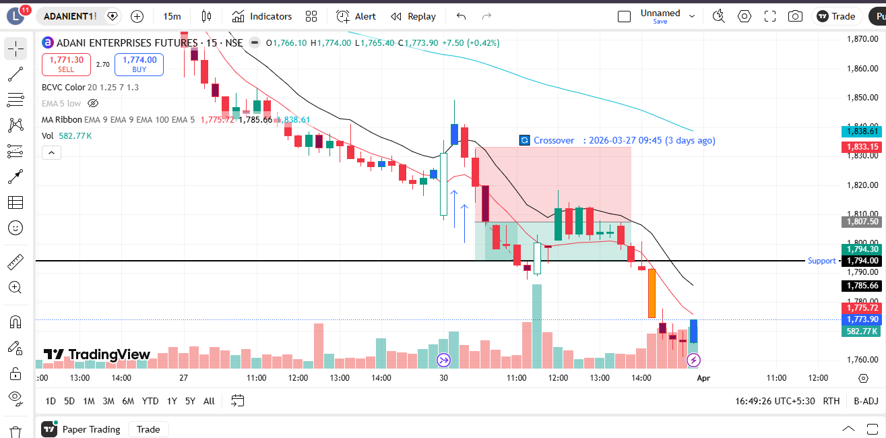
🔴 BEARISH SIGNAL --- ADANIGREEN26AprFUT

Nifty Bias : 🔴 SHORT — Aligned ✅
Crossover : 2026-03-27 10:15 (4 days ago)
Pullback : 2026-03-30 12:15
High ₹831.9 ≥ EMA9(High) ₹831.23
Low ₹825.4 (breakdown level)
Confirm : 2026-03-30 12:45 (+2 candle)
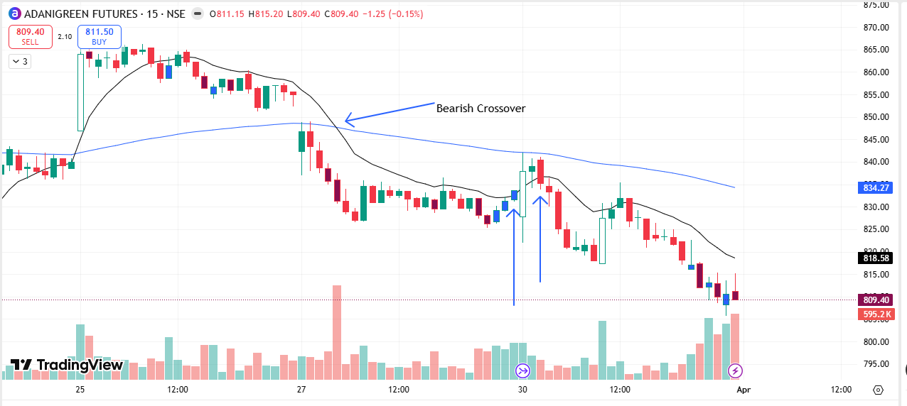
🔴 BEARISH SIGNAL --- ADANIPORTS26AprFUT

Nifty Bias : 🔴 SHORT — Aligned ✅
Crossover : 2026-03-27 10:45 (4 days ago)
Pullback : 2026-03-30 13:30
High ₹1332.3 ≥ EMA9(High) ₹1332.11
Low ₹1326.9 (breakdown level)
Confirm : 2026-03-30 13:45 (+1 candle)
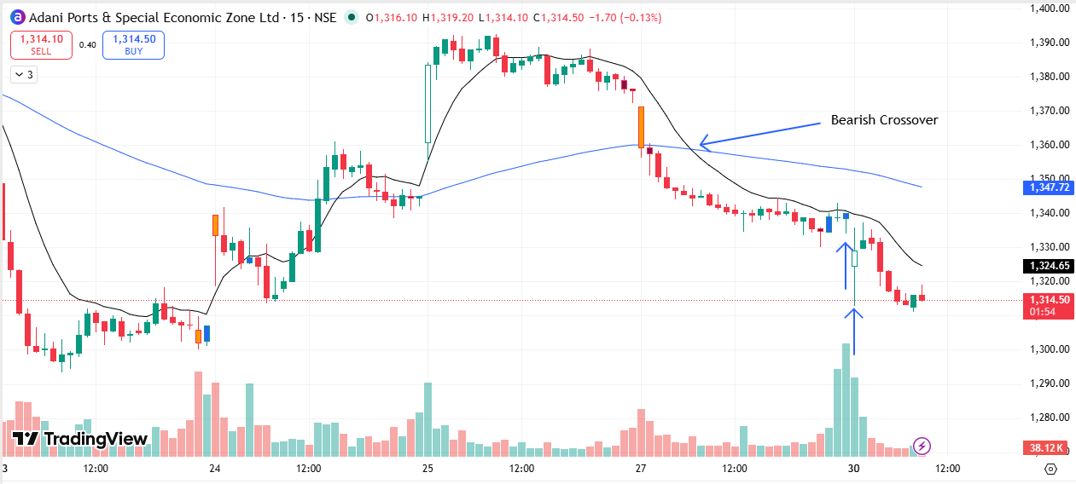
🔴 BEARISH SIGNAL --- ABCAPITAL26AprFUT

Nifty Bias : 🔴 SHORT — Aligned ✅
Crossover : 2026-03-27 10:30 (4 days ago)
Pullback : 2026-03-30 12:15
High ₹298.45 ≥ EMA9(High) ₹298.12
Low ₹296 (breakdown level)
Confirm : 2026-03-30 12:45 (+2 candle)
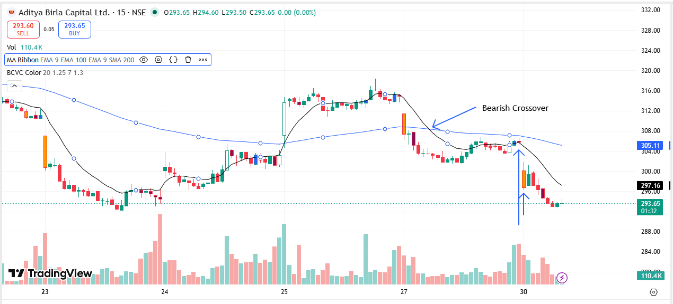
🔴 BEARISH SIGNAL --- ALKEM26AprFUT

Nifty Bias : 🔴 SHORT — Aligned ✅
Crossover : 2026-03-30 09:45 (a day ago)
Pullback : 2026-03-30 13:30
High ₹5346 ≥ EMA9(High) ₹5343.51
Low ₹5335 (breakdown level)
Confirm : 2026-03-30 13:45 (+1 candle)

🔴 BEARISH SIGNAL --- AMBER26AprFUT

Nifty Bias : 🔴 SHORT — Aligned ✅
Crossover : 2026-03-30 11:00 (a day ago)
Pullback : 2026-03-30 12:15
High ₹6532.5 ≥ EMA9(High) ₹6528.46
Low ₹6478 (breakdown level)
Confirm : 2026-03-30 12:45 (+2 candle)

🔴 BEARISH SIGNAL --- AMBUJACEM26AprFUT

Nifty Bias : 🔴 SHORT — Aligned ✅
Crossover : 2026-03-27 10:30 (4 days ago)
Pullback : 2026-03-30 09:45
High ₹412.45 ≥ EMA9(High) ₹412.43
Low ₹410.15 (breakdown level)
Confirm : 2026-03-30 10:15 (+2 candle)

🔴 BEARISH SIGNAL --- ANGELONE26AprFUT

Nifty Bias : 🔴 SHORT — Aligned ✅
Crossover : 2026-03-30 11:45 (a day ago)
Pullback : 2026-03-30 12:00
High ₹233.25 ≥ EMA9(High) ₹233.05
Low ₹231.7 (breakdown level)
Confirm : 2026-03-30 12:30 (+2 candle)

🔴 BEARISH SIGNAL --- ASHOKLEY26AprFUT

Nifty Bias : 🔴 SHORT — Aligned ✅
Crossover : 2026-03-27 10:15 (4 days ago)
Pullback : 2026-03-30 13:30
High ₹157.52 ≥ EMA9(High) ₹157.3
Low ₹156.81 (breakdown level)
Confirm : 2026-03-30 13:45 (+1 candle)

🟢 BULLISH SIGNAL --- ASTRAL26AprFUT

Nifty Bias : 🔴 SHORT — Counter Trend ⚠️
Crossover : 2026-03-30 11:30 (a day ago)
Pullback : 2026-03-30 15:00
Low ₹1581.5 ≤ EMA9(Low) ₹1586.05
High ₹1588.5 (breakout level)
Confirm : 2026-03-30 15:15 (+1 candle)

🟢 BULLISH SIGNAL --- DMART26AprFUT

Nifty Bias : 🔴 SHORT — Counter Trend ⚠️
Crossover : 2026-03-25 09:30 (6 days ago)
Pullback : 2026-03-30 11:45
Low ₹3877.6 ≤ EMA9(Low) ₹3878.04
High ₹3891.7 (breakout level)
Confirm : 2026-03-30 12:00 (+1 candle)
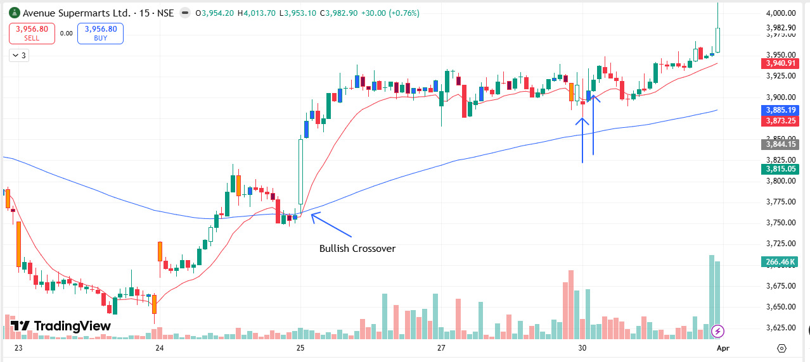
🔴 BEARISH SIGNAL --- BSE26AprFUT

Nifty Bias : 🔴 SHORT — Aligned ✅
Crossover : 2026-03-27 12:15 (4 days ago)
Pullback : 2026-03-30 14:00
High ₹2731 ≥ EMA9(High) ₹2730.19
Low ₹2719.1 (breakdown level)
Confirm : 2026-03-30 14:15 (+1 candle)

🔴 BEARISH SIGNAL --- BAJAJ-AUTO26AprFUT

Nifty Bias : 🔴 SHORT — Aligned ✅
Crossover : 2026-03-27 10:30 (4 days ago)
Pullback : 2026-03-30 13:30
High ₹8771.5 ≥ EMA9(High) ₹8768.96
Low ₹8742 (breakdown level)
Confirm : 2026-03-30 13:45 (+1 candle)

🔴 BEARISH SIGNAL --- BAJFINANCE26AprFUT

Nifty Bias : 🔴 SHORT — Aligned ✅
Crossover : 2026-03-27 13:30 (4 days ago)
Pullback : 2026-03-27 15:15
High ₹850.9 ≥ EMA9(High) ₹850.38
Low ₹846.05 (breakdown level)
Confirm : 2026-03-30 09:15 (+1 candle)
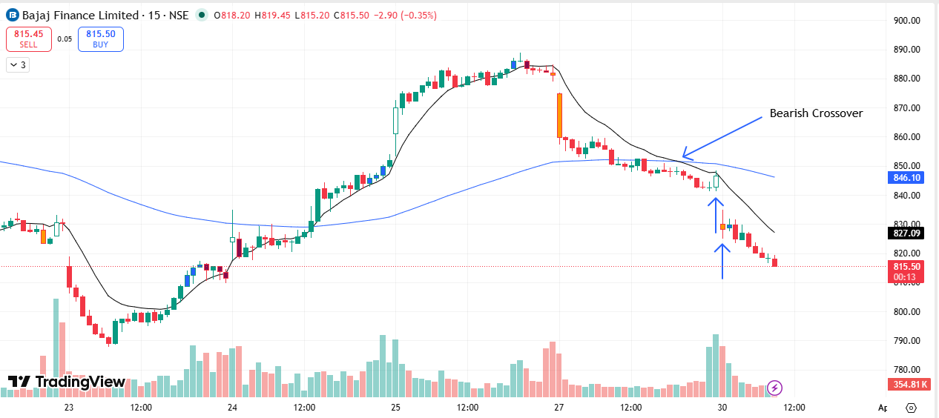
🔴 BEARISH SIGNAL --- BAJAJFINSV26AprFUT

Nifty Bias : 🔴 SHORT — Aligned ✅
Crossover : 2026-03-27 10:45 (4 days ago)
Pullback : 2026-03-27 15:15
High ₹1701.9 ≥ EMA9(High) ₹1701.57
Low ₹1695.6 (breakdown level)
Confirm : 2026-03-30 09:15 (+1 candle)

🔴 BEARISH SIGNAL --- BANDHANBNK26AprFUT

Nifty Bias : 🔴 SHORT — Aligned ✅
Crossover : 2026-03-27 09:45 (4 days ago)
Pullback : 2026-03-27 13:15
High ₹150.65 ≥ EMA9(High) ₹150.48
Low ₹150.16 (breakdown level)
Confirm : 2026-03-27 13:30 (+1 candle)

🔴 BEARISH SIGNAL --- BANKINDIA26AprFUT

Nifty Bias : 🔴 SHORT — Aligned ✅
Crossover : 2026-03-27 09:45 (4 days ago)
Pullback : 2026-03-27 15:15
High ₹145.6 ≥ EMA9(High) ₹145.42
Low ₹144.88 (breakdown level)
Confirm : 2026-03-30 09:15 (+1 candle)
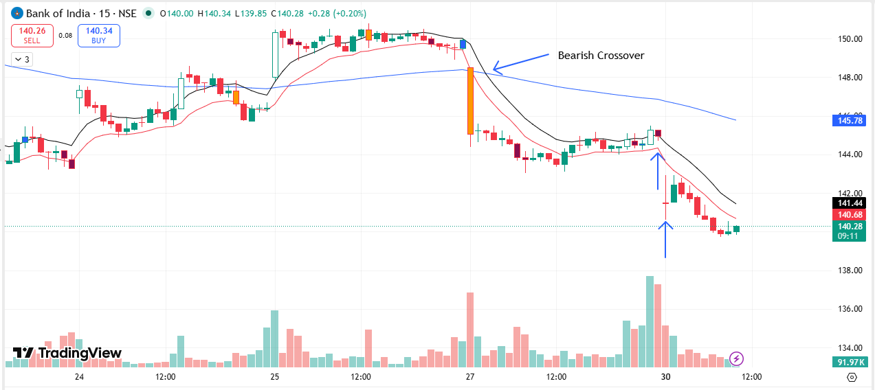
🔴 BEARISH SIGNAL --- BEL26AprFUT

Nifty Bias : 🔴 SHORT — Aligned ✅
Crossover : 2026-03-19 09:45 (12 days ago)
Pullback : 2026-03-30 12:45
High ₹409.9 ≥ EMA9(High) ₹409.5
Low ₹405.85 (breakdown level)
Confirm : 2026-03-30 13:30 (+3 candle)
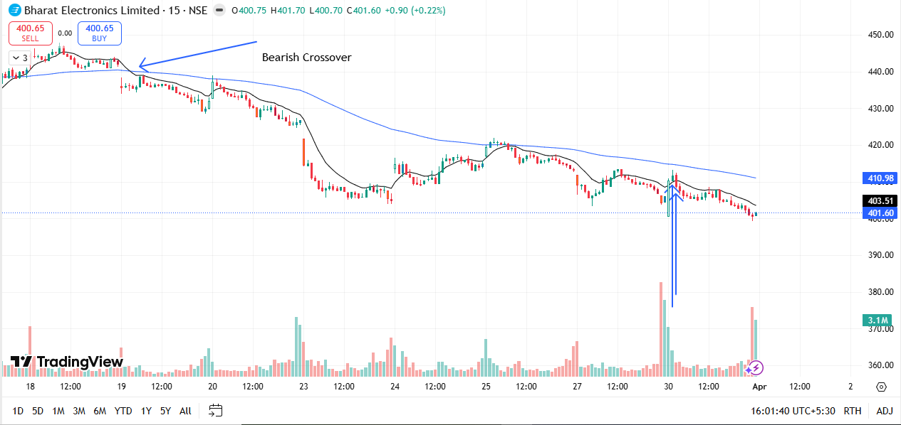
🔴 BEARISH SIGNAL --- BHARATFORG26AprFUT

Nifty Bias : 🔴 SHORT — Aligned ✅
Crossover : 2026-03-30 09:45 (a day ago)
Pullback : 2026-03-30 13:30
High ₹1687.2 ≥ EMA9(High) ₹1684.43
Low ₹1677 (breakdown level)
Confirm : 2026-03-30 13:45 (+1 candle)

🔴 BEARISH SIGNAL --- BHEL26AprFUT

Nifty Bias : 🔴 SHORT — Aligned ✅
Crossover : 2026-03-27 10:45 (4 days ago)
Pullback : 2026-03-30 13:30
High ₹254.7 ≥ EMA9(High) ₹254.11
Low ₹252.4 (breakdown level)
Confirm : 2026-03-30 13:45 (+1 candle)

🔴 BEARISH SIGNAL --- BIOCON26AprFUT

Nifty Bias : 🔴 SHORT — Aligned ✅
Crossover : 2026-03-27 11:15 (4 days ago)
Pullback : 2026-03-30 14:00
High ₹364 ≥ EMA9(High) ₹363.82
Low ₹362.65 (breakdown level)
Confirm : 2026-03-30 14:15 (+1 candle)

🔴 BEARISH SIGNAL --- BLUESTARCO26AprFUT

Nifty Bias : 🔴 SHORT — Aligned ✅
Crossover : 2026-03-27 11:00 (4 days ago)
Pullback : 2026-03-30 13:30
High ₹1632 ≥ EMA9(High) ₹1630.54
Low ₹1622.8 (breakdown level)
Confirm : 2026-03-30 13:45 (+1 candle)

🔴 BEARISH SIGNAL --- BOSCHLTD26AprFUT

Nifty Bias : 🔴 SHORT — Aligned ✅
Crossover : 2026-03-27 10:15 (4 days ago)
Pullback : 2026-03-27 13:30
High ₹30280 ≥ EMA9(High) ₹30235.89
Low ₹30180 (breakdown level)
Confirm : 2026-03-27 13:45 (+1 candle)

🔴 BEARISH SIGNAL --- BRITANNIA26AprFUT

Nifty Bias : 🔴 SHORT — Aligned ✅
Crossover : 2026-03-27 11:00 (4 days ago)
Pullback : 2026-03-30 14:15
High ₹5504 ≥ EMA9(High) ₹5500.99
Low ₹5482.5 (breakdown level)
Confirm : 2026-03-30 14:30 (+1 candle)
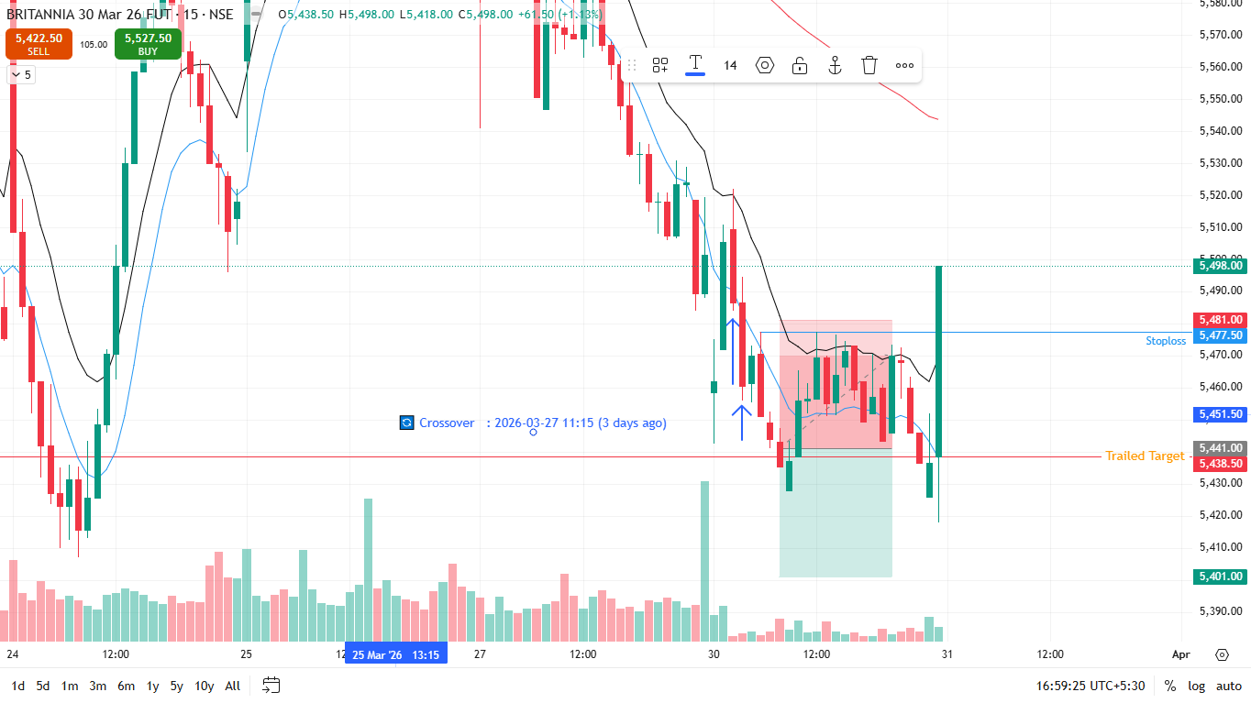
🔴 BEARISH SIGNAL --- CGPOWER26AprFUT

Nifty Bias : 🔴 SHORT — Aligned ✅
Crossover : 2026-03-27 10:45 (4 days ago)
Pullback : 2026-03-30 12:45
High ₹667.7 ≥ EMA9(High) ₹667.33
Low ₹663 (breakdown level)
Confirm : 2026-03-30 13:15 (+2 candle)

🔴 BEARISH SIGNAL --- CANBK26AprFUT

Nifty Bias : 🔴 SHORT — Aligned ✅
Crossover : 2026-03-27 10:00 (4 days ago)
Pullback : 2026-03-27 13:30
High ₹132.68 ≥ EMA9(High) ₹132.42
Low ₹132.1 (breakdown level)
Confirm : 2026-03-27 13:45 (+1 candle)

🔴 BEARISH SIGNAL --- CDSL26AprFUT

Nifty Bias : 🔴 SHORT — Aligned ✅
Crossover : 2026-03-27 11:00 (4 days ago)
Pullback : 2026-03-30 12:00
High ₹1143.5 ≥ EMA9(High) ₹1140.87
Low ₹1135 (breakdown level)
Confirm : 2026-03-30 12:15 (+1 candle)

🔴 BEARISH SIGNAL --- CHOLAFIN26AprFUT

Nifty Bias : 🔴 SHORT — Aligned ✅
Crossover : 2026-03-27 10:30 (4 days ago)
Pullback : 2026-03-27 13:45
High ₹1449.6 ≥ EMA9(High) ₹1446.48
Low ₹1439.3 (breakdown level)
Confirm : 2026-03-27 14:15 (+2 candle)

🔴 BEARISH SIGNAL --- CIPLA26AprFUT

Nifty Bias : 🔴 SHORT — Aligned ✅
Crossover : 2026-03-27 13:00 (4 days ago)
Pullback : 2026-03-30 14:00
High ₹1237.3 ≥ EMA9(High) ₹1235.34
Low ₹1231.8 (breakdown level)
Confirm : 2026-03-30 14:15 (+1 candle)

🔴 BEARISH SIGNAL --- COFORGE26AprFUT

Nifty Bias : 🔴 SHORT — Aligned ✅
Crossover : 2026-03-30 10:30 (a day ago)
Pullback : 2026-03-30 13:30
High ₹1137.9 ≥ EMA9(High) ₹1135.3
Low ₹1130.5 (breakdown level)
Confirm : 2026-03-30 13:45 (+1 candle)
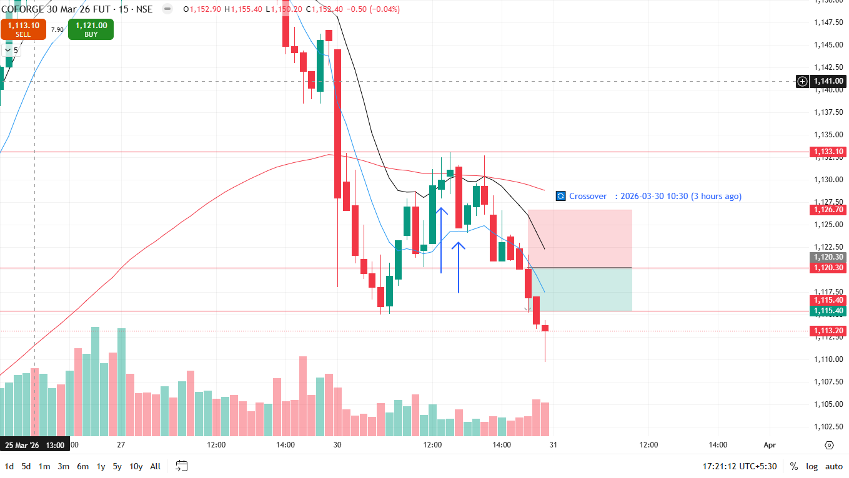
🔴 BEARISH SIGNAL --- COLPAL26AprFUT

Nifty Bias : 🔴 SHORT — Aligned ✅
Crossover : 2026-03-27 12:30 (4 days ago)
Pullback : 2026-03-27 14:30
High ₹1894.1 ≥ EMA9(High) ₹1891.74
Low ₹1884.9 (breakdown level)
Confirm : 2026-03-27 14:45 (+1 candle)
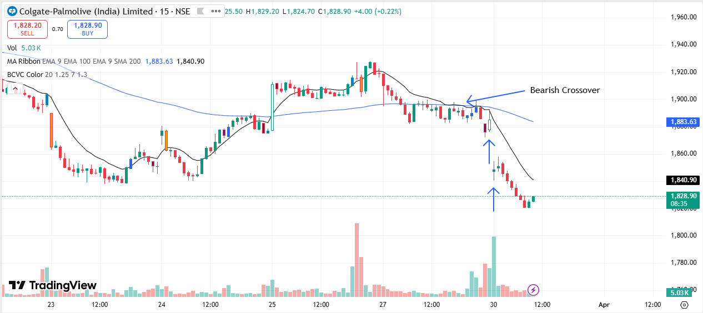
🔴 BEARISH SIGNAL --- CAMS26AprFUT

Nifty Bias : 🔴 SHORT — Aligned ✅
Crossover : 2026-03-27 15:00 (4 days ago)
Pullback : 2026-03-30 13:15
High ₹634 ≥ EMA9(High) ₹632.08
Low ₹629.05 (breakdown level)
Confirm : 2026-03-30 13:30 (+1 candle)

🔴 BEARISH SIGNAL --- CONCOR26AprFUT

Nifty Bias : 🔴 SHORT — Aligned ✅
Crossover : 2026-03-27 10:30 (4 days ago)
Pullback : 2026-03-30 14:00
High ₹432.5 ≥ EMA9(High) ₹432.3
Low ₹430.9 (breakdown level)
Confirm : 2026-03-30 14:15 (+1 candle)
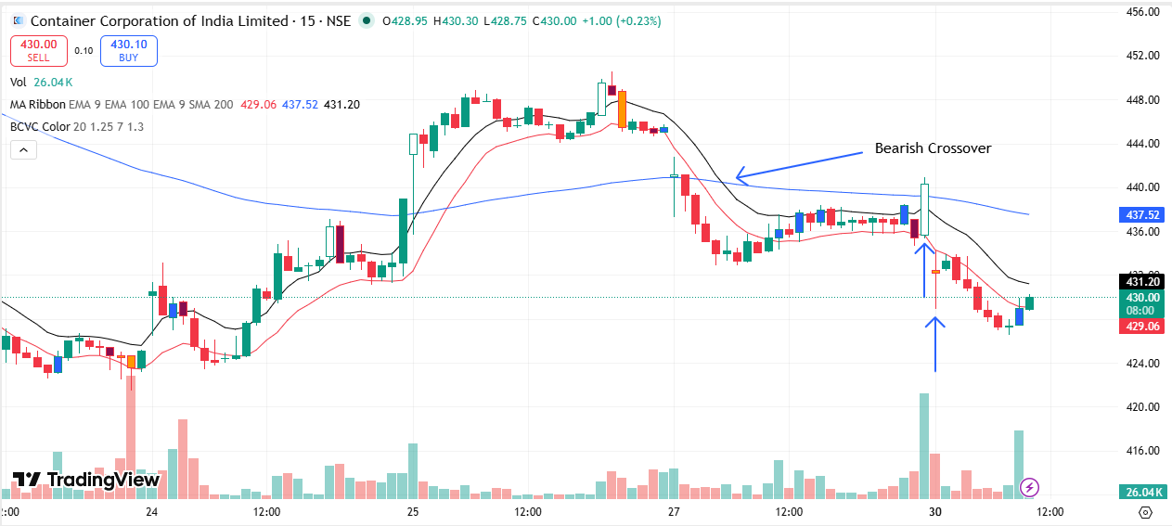
🔴 BEARISH SIGNAL --- CROMPTON26AprFUT

Nifty Bias : 🔴 SHORT — Aligned ✅
Crossover : 2026-03-27 10:15 (4 days ago)
Pullback : 2026-03-30 13:15
High ₹229.2 ≥ EMA9(High) ₹228.87
Low ₹227.3 (breakdown level)
Confirm : 2026-03-30 13:30 (+1 candle)

🔴 BEARISH SIGNAL --- CUMMINSIND26AprFUT

Nifty Bias : 🔴 SHORT — Aligned ✅
Crossover : 2026-03-27 13:30 (4 days ago)
Pullback : 2026-03-30 14:15
High ₹4577 ≥ EMA9(High) ₹4572.45
Low ₹4564.4 (breakdown level)
Confirm : 2026-03-30 14:30 (+1 candle)

🔴 BEARISH SIGNAL --- DLF26AprFUT

Nifty Bias : 🔴 SHORT — Aligned ✅
Crossover : 2026-03-27 09:45 (4 days ago)
Pullback : 2026-03-27 13:30
High ₹531 ≥ EMA9(High) ₹530.69
Low ₹528.45 (breakdown level)
Confirm : 2026-03-27 13:45 (+1 candle)

🔴 BEARISH SIGNAL --- DABUR26AprFUT

Nifty Bias : 🔴 SHORT — Aligned ✅
Crossover : 2026-03-27 10:00 (4 days ago)
Pullback : 2026-03-27 12:30
High ₹427.35 ≥ EMA9(High) ₹427.26
Low ₹425.35 (breakdown level)
Confirm : 2026-03-27 13:00 (+2 candle)

🔴 BEARISH SIGNAL --- DELHIVERY26AprFUT

Nifty Bias : 🔴 SHORT — Aligned ✅
Crossover : 2026-03-30 10:30 (a day ago)
Pullback : 2026-03-30 14:00
High ₹422.2 ≥ EMA9(High) ₹421.44
Low ₹419.95 (breakdown level)
Confirm : 2026-03-30 14:45 (+3 candle)

🔴 BEARISH SIGNAL --- DIVISLAB26AprFUT

Nifty Bias : 🔴 SHORT — Aligned ✅
Crossover : 2026-03-25 15:15 (6 days ago)
Pullback : 2026-03-30 14:15
High ₹5977 ≥ EMA9(High) ₹5975.7
Low ₹5965 (breakdown level)
Confirm : 2026-03-30 14:30 (+1 candle)
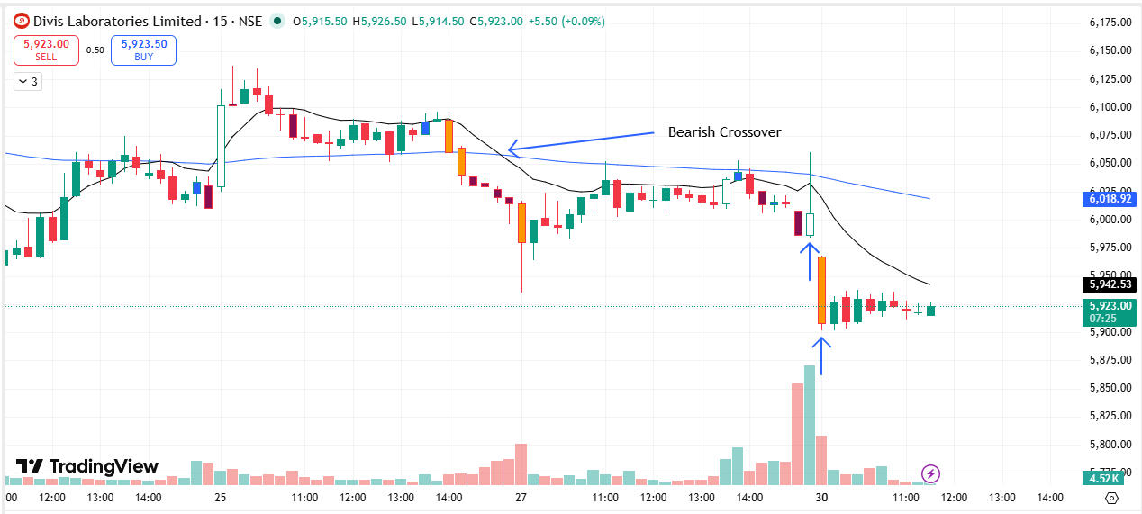
🔴 BEARISH SIGNAL --- DIXON26AprFUT

Nifty Bias : 🔴 SHORT — Aligned ✅
Crossover : 2026-03-27 10:00 (4 days ago)
Pullback : 2026-03-30 12:45
High ₹9785 ≥ EMA9(High) ₹9770.3
Low ₹9711 (breakdown level)
Confirm : 2026-03-30 13:15 (+2 candle)

🔴 BEARISH SIGNAL --- DRREDDY26AprFUT

Nifty Bias : 🔴 SHORT — Aligned ✅
Crossover : 2026-03-30 09:30 (a day ago)
Pullback : 2026-03-30 12:30
High ₹1275.1 ≥ EMA9(High) ₹1274.16
Low ₹1271.1 (breakdown level)
Confirm : 2026-03-30 12:45 (+1 candle)

🔴 BEARISH SIGNAL --- ETERNAL26AprFUT

Nifty Bias : 🔴 SHORT — Aligned ✅
Crossover : 2026-03-27 14:45 (4 days ago)
Pullback : 2026-03-30 14:45
High ₹230.65 ≥ EMA9(High) ₹230.51
Low ₹229.77 (breakdown level)
Confirm : 2026-03-30 15:15 (+2 candle)

🔴 BEARISH SIGNAL --- EICHERMOT26AprFUT

Nifty Bias : 🔴 SHORT — Aligned ✅
Crossover : 2026-03-27 10:30 (4 days ago)
Pullback : 2026-03-27 14:30
High ₹6870 ≥ EMA9(High) ₹6865.02
Low ₹6835 (breakdown level)
Confirm : 2026-03-27 15:00 (+2 candle)

🔴 BEARISH SIGNAL --- FORTIS26AprFUT

Nifty Bias : 🔴 SHORT — Aligned ✅
Crossover : 2026-03-27 15:15 (4 days ago)
Pullback : 2026-03-30 13:45
High ₹804.95 ≥ EMA9(High) ₹803.69
Low ₹799.35 (breakdown level)
Confirm : 2026-03-30 14:00 (+1 candle)

🔴 BEARISH SIGNAL --- GODREJCP26AprFUT

Nifty Bias : 🔴 SHORT — Aligned ✅
Crossover : 2026-03-27 11:00 (4 days ago)
Pullback : 2026-03-30 13:30
High ₹1000.5 ≥ EMA9(High) ₹1000.5
Low ₹996.9 (breakdown level)
Confirm : 2026-03-30 13:45 (+1 candle)

🔴 BEARISH SIGNAL --- GODREJPROP26AprFUT

Nifty Bias : 🔴 SHORT — Aligned ✅
Crossover : 2026-03-27 09:45 (4 days ago)
Pullback : 2026-03-30 14:00
High ₹1484.3 ≥ EMA9(High) ₹1483.51
Low ₹1477 (breakdown level)
Confirm : 2026-03-30 14:30 (+2 candle)
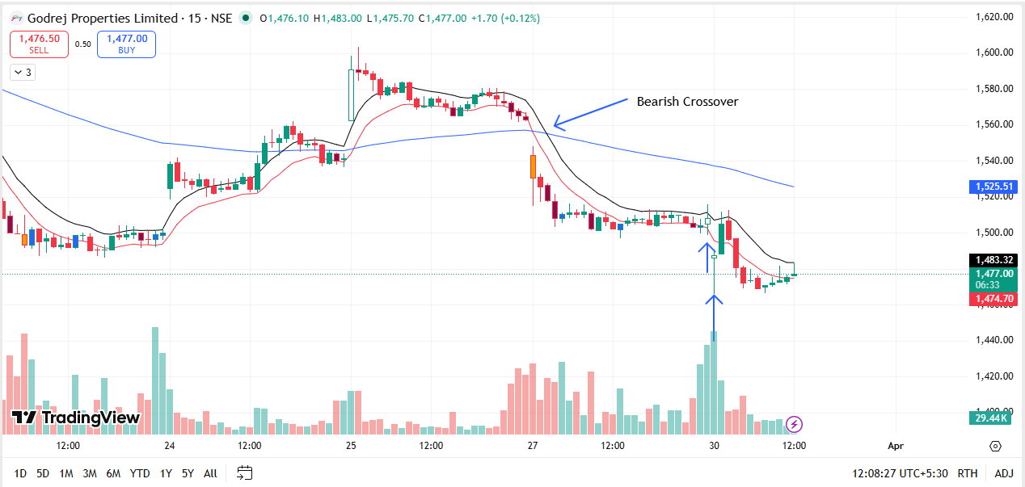
🔴 BEARISH SIGNAL --- GRASIM26AprFUT

Nifty Bias : 🔴 SHORT — Aligned ✅
Crossover : 2026-03-30 10:00 (a day ago)
Pullback : 2026-03-30 14:00
High ₹2590.9 ≥ EMA9(High) ₹2590.35
Low ₹2576.3 (breakdown level)
Confirm : 2026-03-30 14:15 (+1 candle)

🔴 BEARISH SIGNAL --- HCLTECH26AprFUT

Nifty Bias : 🔴 SHORT — Aligned ✅
Crossover : 2026-03-27 14:15 (4 days ago)
Pullback : 2026-03-30 13:30
High ₹1335.8 ≥ EMA9(High) ₹1333.89
Low ₹1327.3 (breakdown level)
Confirm : 2026-03-30 13:45 (+1 candle)

🔴 BEARISH SIGNAL --- HDFCAMC26AprFUT

Nifty Bias : 🔴 SHORT — Aligned ✅
Crossover : 2026-03-27 10:00 (4 days ago)
Pullback : 2026-03-27 14:00
High ₹2336.4 ≥ EMA9(High) ₹2334.48
Low ₹2328.6 (breakdown level)
Confirm : 2026-03-27 14:15 (+1 candle)
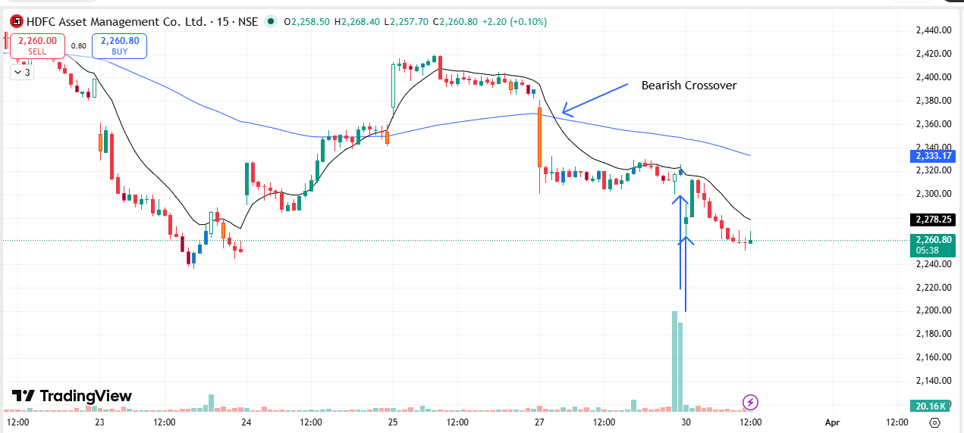
🔴 BEARISH SIGNAL --- HDFCBANK26AprFUT

Nifty Bias : 🔴 SHORT — Aligned ✅
Crossover : 2026-03-27 09:45 (4 days ago)
Pullback : 2026-03-27 14:15
High ₹766.85 ≥ EMA9(High) ₹766.21
Low ₹764.4 (breakdown level)
Confirm : 2026-03-27 14:30 (+1 candle)

🔴 BEARISH SIGNAL --- HDFCLIFE26AprFUT

Nifty Bias : 🔴 SHORT — Aligned ✅
Crossover : 2026-03-27 09:30 (4 days ago)
Pullback : 2026-03-30 09:45
High ₹612.9 ≥ EMA9(High) ₹612.11
Low ₹607.2 (breakdown level)
Confirm : 2026-03-30 10:00 (+1 candle)
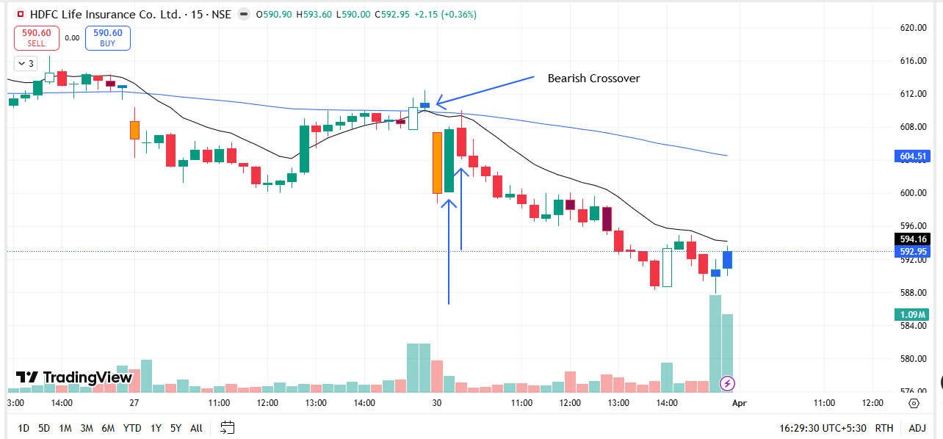
🔴 BEARISH SIGNAL --- HAVELLS26AprFUT

Nifty Bias : 🔴 SHORT — Aligned ✅
Crossover : 2026-03-27 10:00 (4 days ago)
Pullback : 2026-03-30 14:15
High ₹1201.1 ≥ EMA9(High) ₹1200.28
Low ₹1196 (breakdown level)
Confirm : 2026-03-30 14:30 (+1 candle)
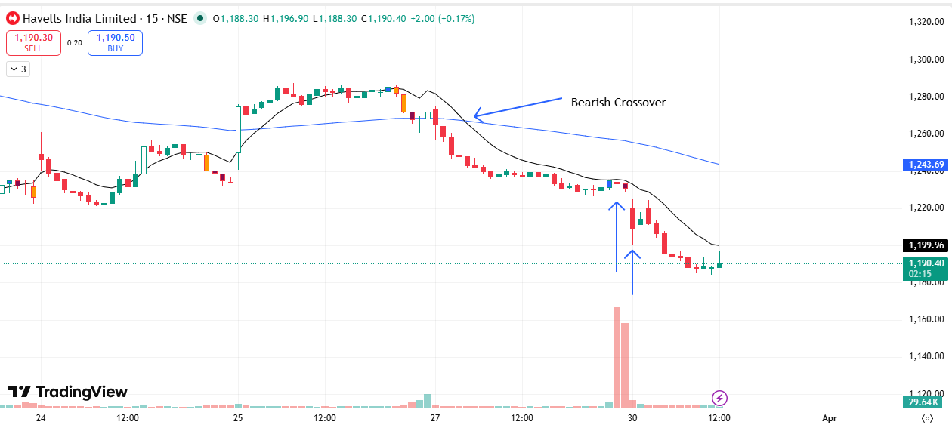
🔴 BEARISH SIGNAL --- HEROMOTOCO26AprFUT

Nifty Bias : 🔴 SHORT — Aligned ✅
Crossover : 2026-03-27 10:00 (4 days ago)
Pullback : 2026-03-30 13:30
High ₹5147 ≥ EMA9(High) ₹5141.46
Low ₹5118.5 (breakdown level)
Confirm : 2026-03-30 13:45 (+1 candle)

🔴 BEARISH SIGNAL --- HAL26AprFUT

Nifty Bias : 🔴 SHORT — Aligned ✅
Crossover : 2026-03-19 09:45 (12 days ago)
Pullback : 2026-03-30 10:00
High ₹3620.9 ≥ EMA9(High) ₹3619.94
Low ₹3593.4 (breakdown level)
Confirm : 2026-03-30 10:30 (+2 candle)
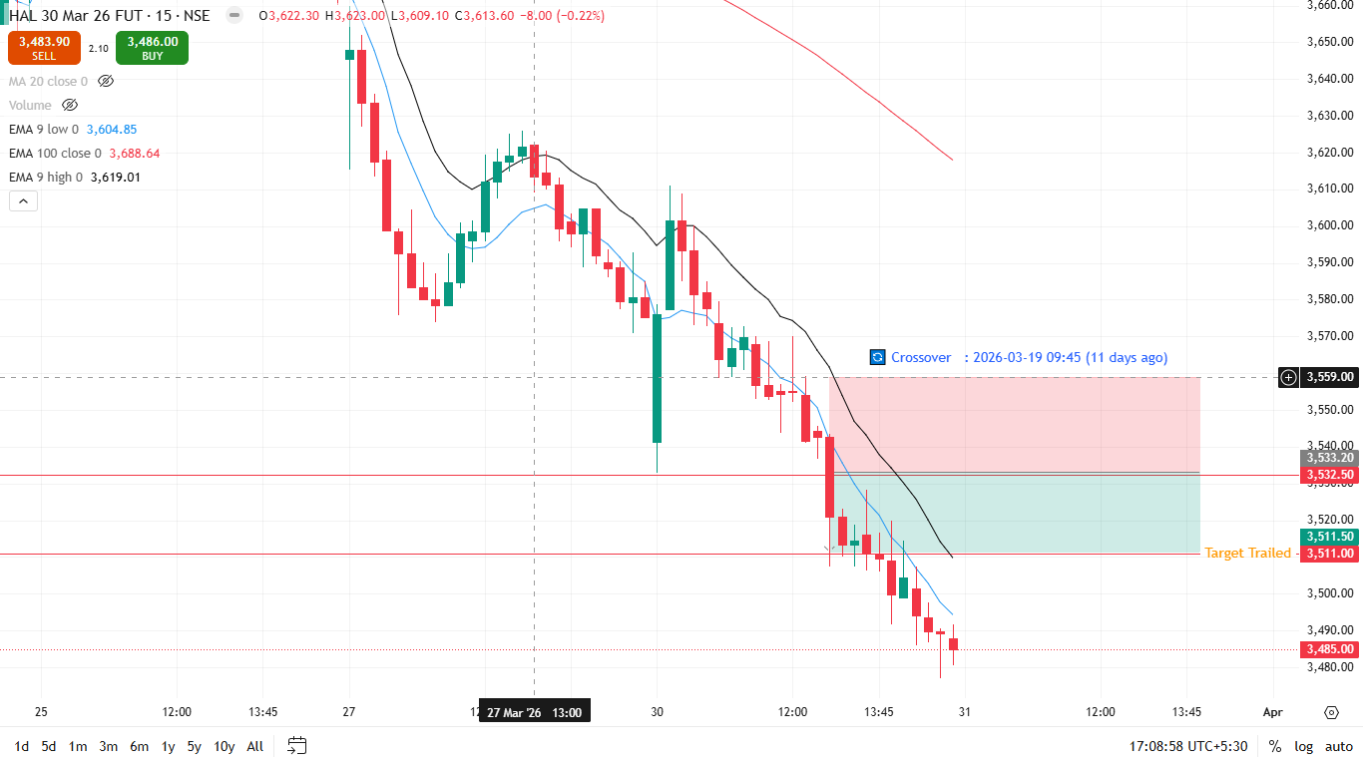
🔴 BEARISH SIGNAL --- HINDZINC26AprFUT

Nifty Bias : 🔴 SHORT — Aligned ✅
Crossover : 2026-03-30 10:45 (a day ago)
Pullback : 2026-03-30 12:30
High ₹513 ≥ EMA9(High) ₹512.77
Low ₹511.55 (breakdown level)
Confirm : 2026-03-30 12:45 (+1 candle)

🔴 BEARISH SIGNAL --- POWERINDIA26AprFUT

Nifty Bias : 🔴 SHORT — Aligned ✅
Crossover : 2026-03-27 13:30 (4 days ago)
Pullback : 2026-03-30 13:15
High ₹24545 ≥ EMA9(High) ₹24525.95
Low ₹24425 (breakdown level)
Confirm : 2026-03-30 13:30 (+1 candle)

🔴 BEARISH SIGNAL --- HUDCO26AprFUT

Nifty Bias : 🔴 SHORT — Aligned ✅
Crossover : 2026-03-27 10:45 (4 days ago)
Pullback : 2026-03-27 14:30
High ₹170.31 ≥ EMA9(High) ₹170.2
Low ₹169.53 (breakdown level)
Confirm : 2026-03-27 15:00 (+2 candle)

🔴 BEARISH SIGNAL --- ICICIBANK26AprFUT

Nifty Bias : 🔴 SHORT — Aligned ✅
Crossover : 2026-03-27 11:15 (4 days ago)
Pullback : 2026-03-30 14:00
High ₹1224.4 ≥ EMA9(High) ₹1222.94
Low ₹1220.5 (breakdown level)
Confirm : 2026-03-30 14:15 (+1 candle)

🔴 BEARISH SIGNAL --- ICICIPRULI26AprFUT

Nifty Bias : 🔴 SHORT — Aligned ✅
Crossover : 2026-03-25 13:15 (6 days ago)
Pullback : 2026-03-27 14:45
High ₹536.35 ≥ EMA9(High) ₹535.17
Low ₹534.9 (breakdown level)
Confirm : 2026-03-27 15:00 (+1 candle)
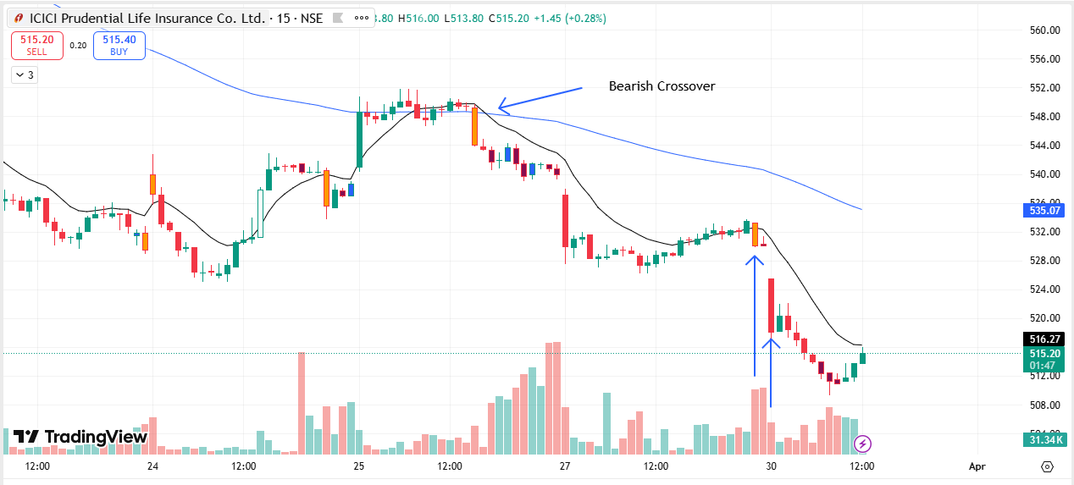
🔴 BEARISH SIGNAL --- IDFCFIRSTB26AprFUT

Nifty Bias : 🔴 SHORT — Aligned ✅
Crossover : 2026-03-27 10:45 (4 days ago)
Pullback : 2026-03-27 15:15
High ₹62.23 ≥ EMA9(High) ₹62.09
Low ₹62.02 (breakdown level)
Confirm : 2026-03-30 09:15 (+1 candle)
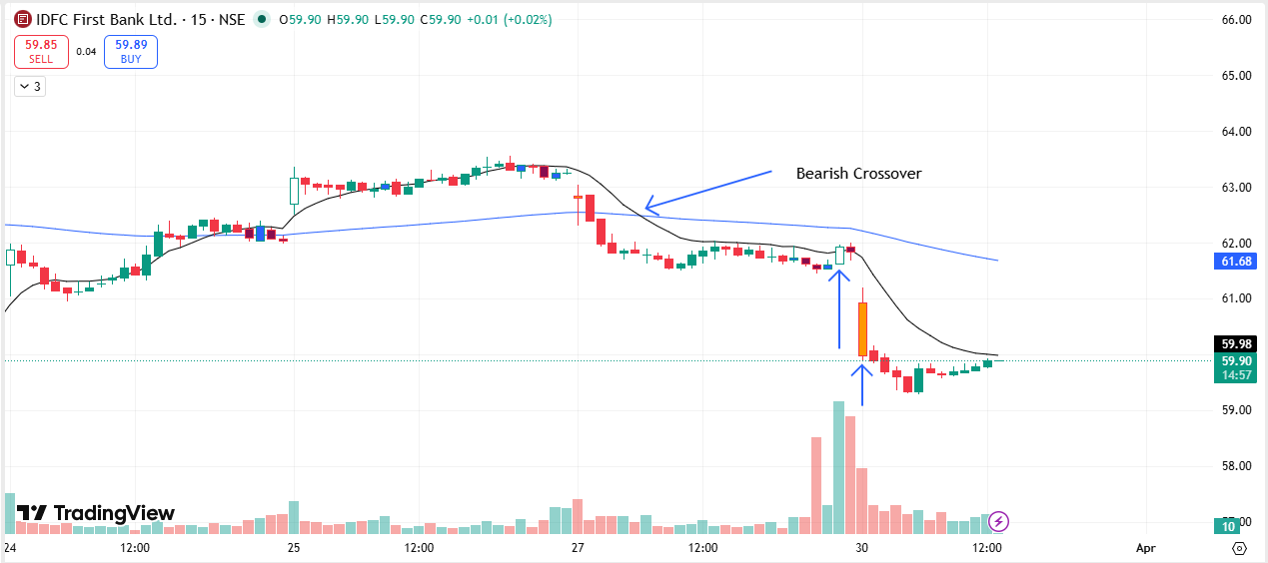
🔴 BEARISH SIGNAL --- ITC26AprFUT

Nifty Bias : 🔴 SHORT — Aligned ✅
Crossover : 2026-03-27 13:30 (4 days ago)
Pullback : 2026-03-30 12:00
High ₹293.3 ≥ EMA9(High) ₹293.3
Low ₹291.75 (breakdown level)
Confirm : 2026-03-30 12:45 (+3 candle)
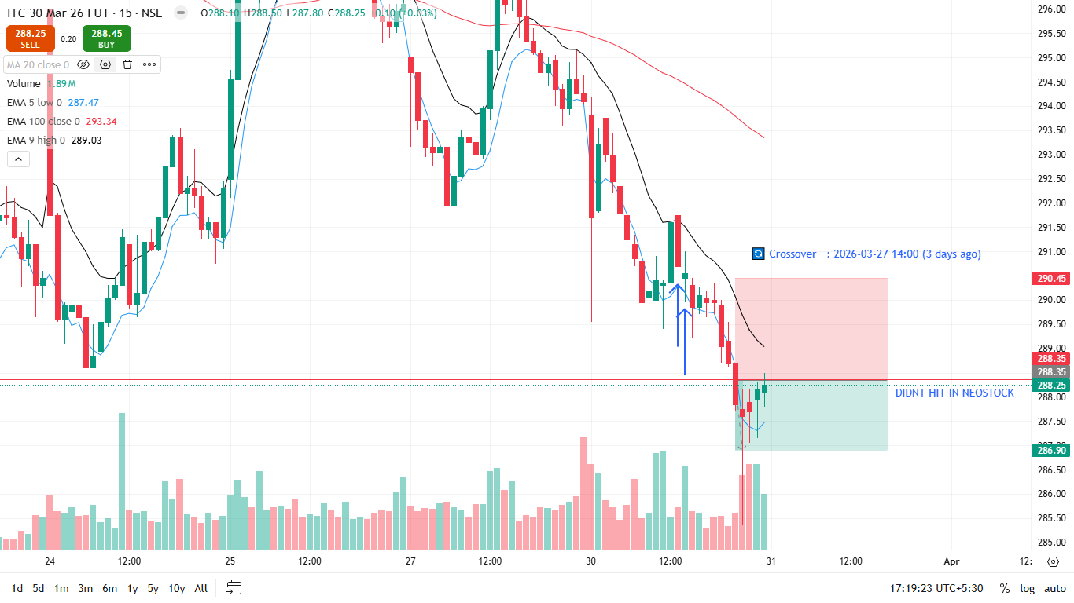
🔴 BEARISH SIGNAL --- INDIANB26AprFUT

Nifty Bias : 🔴 SHORT — Aligned ✅
Crossover : 2026-03-27 12:00 (4 days ago)
Pullback : 2026-03-30 13:00
High ₹856.8 ≥ EMA9(High) ₹856.08
Low ₹851.1 (breakdown level)
Confirm : 2026-03-30 13:30 (+2 candle)

🔴 BEARISH SIGNAL --- INDUSTOWER26AprFUT

Nifty Bias : 🔴 SHORT — Aligned ✅
Crossover : 2026-03-30 09:15 (a day ago)
Pullback : 2026-03-30 14:00
High ₹423.5 ≥ EMA9(High) ₹423.11
Low ₹422.1 (breakdown level)
Confirm : 2026-03-30 14:15 (+1 candle)

🔴 BEARISH SIGNAL --- INDUSINDBK26AprFUT

Nifty Bias : 🔴 SHORT — Aligned ✅
Crossover : 2026-03-27 10:30 (4 days ago)
Pullback : 2026-03-27 13:15
High ₹803.55 ≥ EMA9(High) ₹802.75
Low ₹800.05 (breakdown level)
Confirm : 2026-03-27 13:30 (+1 candle)
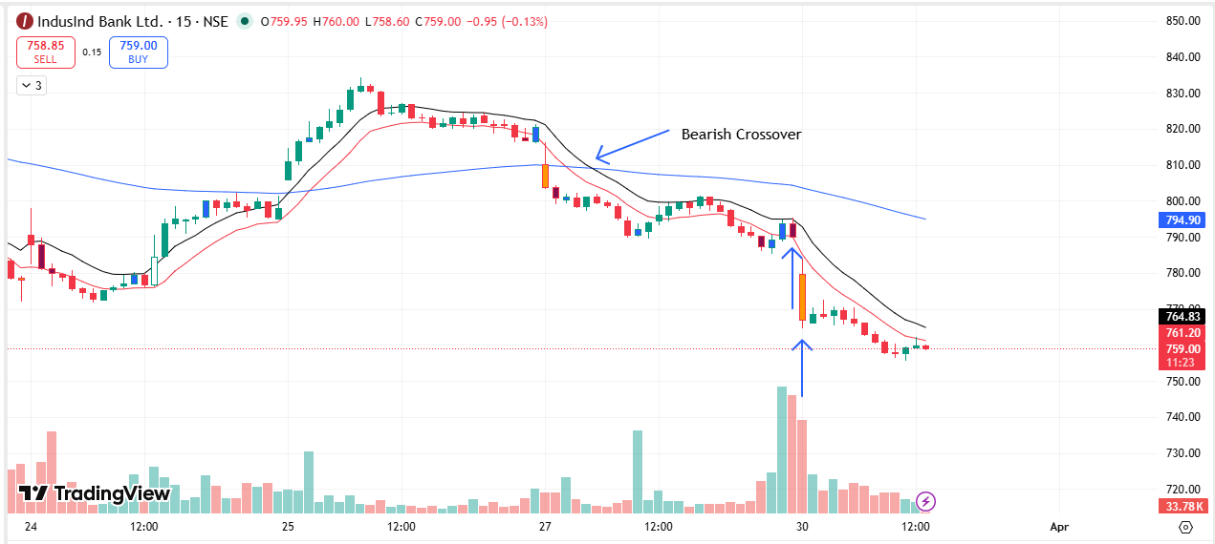
🔴 BEARISH SIGNAL --- NAUKRI26AprFUT

Nifty Bias : 🔴 SHORT — Aligned ✅
Crossover : 2026-03-30 09:30 (a day ago)
Pullback : 2026-03-30 13:15
High ₹971.2 ≥ EMA9(High) ₹971.07
Low ₹968.4 (breakdown level)
Confirm : 2026-03-30 13:30 (+1 candle)

🔴 BEARISH SIGNAL --- INOXWIND26AprFUT

Nifty Bias : 🔴 SHORT — Aligned ✅
Crossover : 2026-03-27 14:15 (4 days ago)
Pullback : 2026-03-30 13:00
High ₹78.35 ≥ EMA9(High) ₹78.34
Low ₹77.8 (breakdown level)
Confirm : 2026-03-30 13:30 (+2 candle)

🔴 BEARISH SIGNAL --- INDIGO26AprFUT

Nifty Bias : 🔴 SHORT — Aligned ✅
Crossover : 2026-03-27 11:45 (4 days ago)
Pullback : 2026-03-27 13:45
High ₹4175.8 ≥ EMA9(High) ₹4175.71
Low ₹4161.6 (breakdown level)
Confirm : 2026-03-27 14:00 (+1 candle)

🔴 BEARISH SIGNAL --- JINDALSTEL26AprFUT

Nifty Bias : 🔴 SHORT — Aligned ✅
Crossover : 2026-03-27 15:15 (4 days ago)
Pullback : 2026-03-30 14:00
High ₹1125.3 ≥ EMA9(High) ₹1124.42
Low ₹1117.5 (breakdown level)
Confirm : 2026-03-30 14:15 (+1 candle)

🔴 BEARISH SIGNAL --- JSWENERGY26AprFUT

Nifty Bias : 🔴 SHORT — Aligned ✅
Crossover : 2026-03-27 09:45 (4 days ago)
Pullback : 2026-03-30 12:00
High ₹479.45 ≥ EMA9(High) ₹479.26
Low ₹476.75 (breakdown level)
Confirm : 2026-03-30 12:45 (+3 candle)

🔴 BEARISH SIGNAL --- JSWSTEEL26AprFUT

Nifty Bias : 🔴 SHORT — Aligned ✅
Crossover : 2026-03-27 12:45 (4 days ago)
Pullback : 2026-03-30 14:00
High ₹1139.6 ≥ EMA9(High) ₹1138.05
Low ₹1133.5 (breakdown level)
Confirm : 2026-03-30 14:15 (+1 candle)

🔴 BEARISH SIGNAL --- JIOFIN26AprFUT

Nifty Bias : 🔴 SHORT — Aligned ✅
Crossover : 2026-03-27 10:15 (4 days ago)
Pullback : 2026-03-27 13:15
High ₹234.7 ≥ EMA9(High) ₹234.45
Low ₹233.75 (breakdown level)
Confirm : 2026-03-27 13:45 (+2 candle)
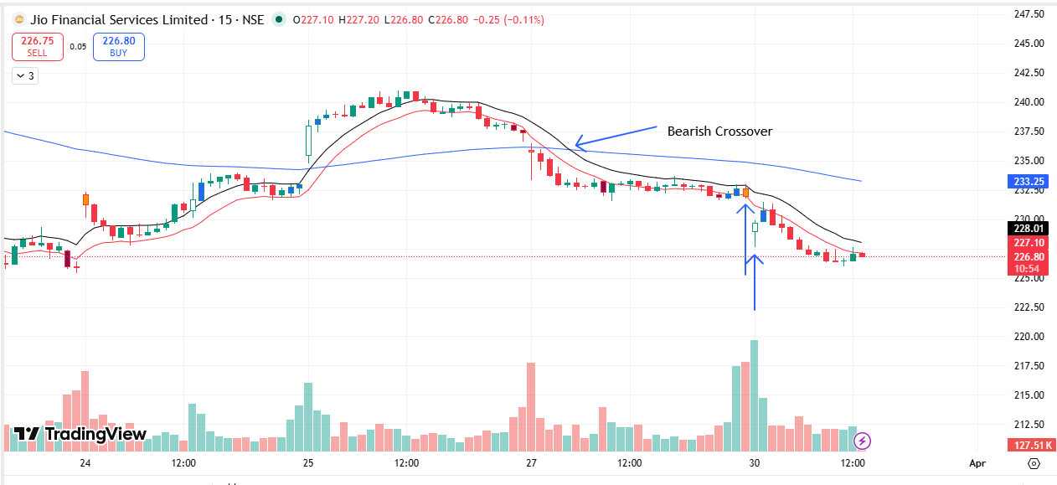
🔴 BEARISH SIGNAL --- JUBLFOOD26AprFUT

Nifty Bias : 🔴 SHORT — Aligned ✅
Crossover : 2026-03-30 09:15 (a day ago)
Pullback : 2026-03-30 12:00
High ₹436.9 ≥ EMA9(High) ₹436.61
Low ₹432.9 (breakdown level)
Confirm : 2026-03-30 12:45 (+3 candle)
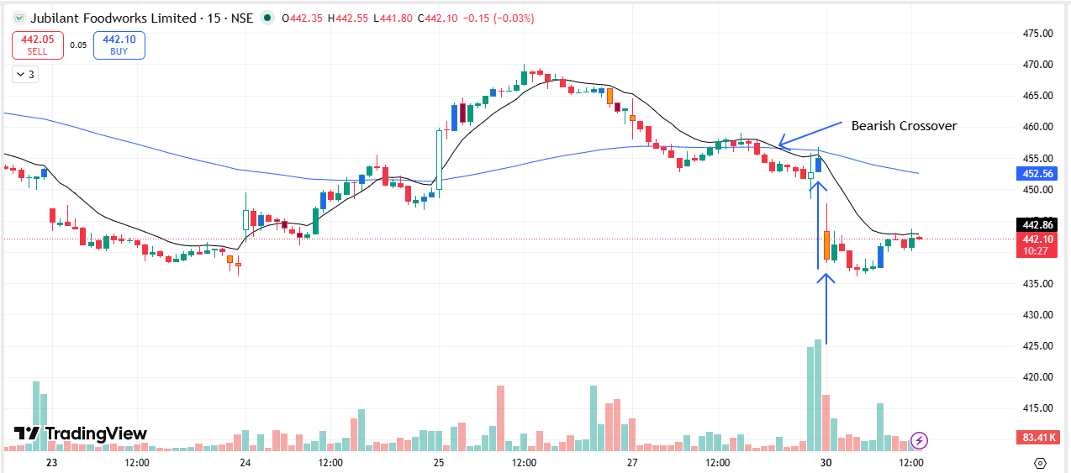
🔴 BEARISH SIGNAL --- KEI26AprFUT

Nifty Bias : 🔴 SHORT — Aligned ✅
Crossover : 2026-03-27 10:00 (4 days ago)
Pullback : 2026-03-30 15:00
High ₹3947.5 ≥ EMA9(High) ₹3933.43
Low ₹3913.5 (breakdown level)
Confirm : 2026-03-30 15:15 (+1 candle)

🔴 BEARISH SIGNAL --- KFINTECH26AprFUT

Nifty Bias : 🔴 SHORT — Aligned ✅
Crossover : 2026-03-27 12:15 (4 days ago)
Pullback : 2026-03-27 15:15
High ₹891.2 ≥ EMA9(High) ₹890.86
Low ₹881.2 (breakdown level)
Confirm : 2026-03-30 09:15 (+1 candle)
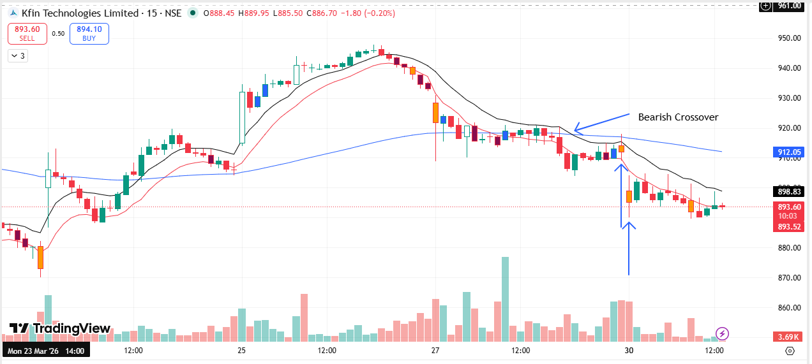
🔴 BEARISH SIGNAL --- KOTAKBANK26AprFUT

Nifty Bias : 🔴 SHORT — Aligned ✅
Crossover : 2026-03-27 10:00 (4 days ago)
Pullback : 2026-03-30 13:00
High ₹358.7 ≥ EMA9(High) ₹358.65
Low ₹357.15 (breakdown level)
Confirm : 2026-03-30 13:15 (+1 candle)
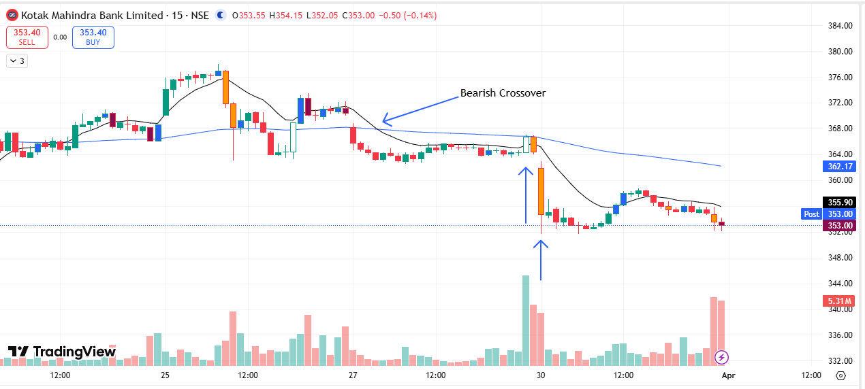
🔴 BEARISH SIGNAL --- LTF26AprFUT

Nifty Bias : 🔴 SHORT — Aligned ✅
Crossover : 2026-03-27 10:15 (4 days ago)
Pullback : 2026-03-30 12:00
High ₹243.4 ≥ EMA9(High) ₹243.05
Low ₹242.3 (breakdown level)
Confirm : 2026-03-30 12:15 (+1 candle)
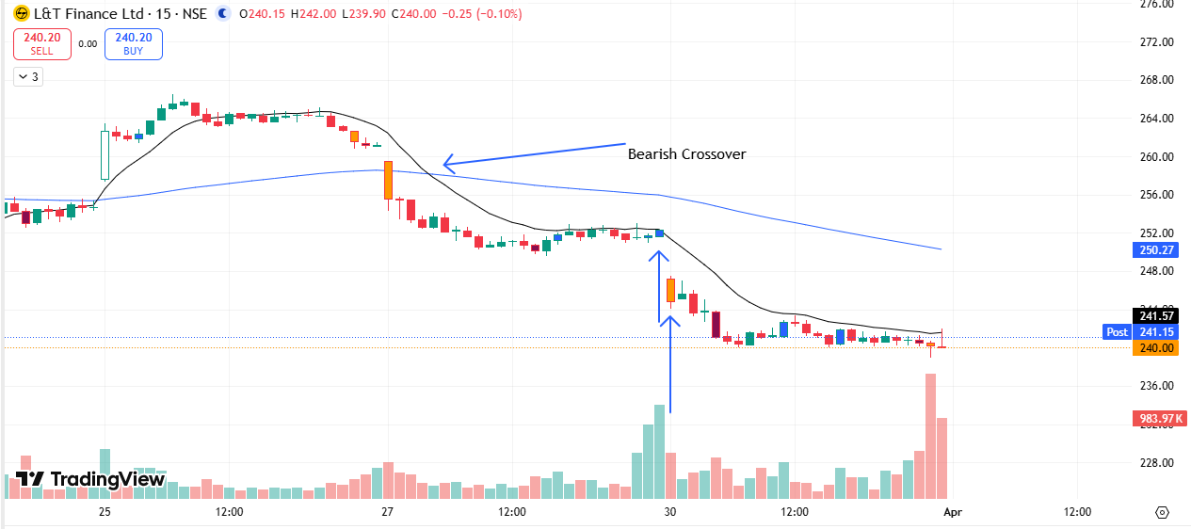
🔴 BEARISH SIGNAL --- LTM26AprFUT

Nifty Bias : 🔴 SHORT — Aligned ✅
Crossover : 2026-03-27 13:15 (4 days ago)
Pullback : 2026-03-30 12:30
High ₹4095.8 ≥ EMA9(High) ₹4091.76
Low ₹4084.6 (breakdown level)
Confirm : 2026-03-30 12:45 (+1 candle)

🔴 BEARISH SIGNAL --- LT26AprFUT

Nifty Bias : 🔴 SHORT — Aligned ✅
Crossover : 2026-03-30 10:45 (a day ago)
Pullback : 2026-03-30 12:45
High ₹3551.8 ≥ EMA9(High) ₹3547.19
Low ₹3536.1 (breakdown level)
Confirm : 2026-03-30 13:15 (+2 candle)

🔴 BEARISH SIGNAL --- LICI26AprFUT

Nifty Bias : 🔴 SHORT — Aligned ✅
Crossover : 2026-03-27 11:15 (4 days ago)
Pullback : 2026-03-27 15:15
High ₹766.15 ≥ EMA9(High) ₹765.26
Low ₹762.1 (breakdown level)
Confirm : 2026-03-30 09:15 (+1 candle)

🔴 BEARISH SIGNAL --- LODHA26AprFUT

Nifty Bias : 🔴 SHORT — Aligned ✅
Crossover : 2026-03-19 09:30 (12 days ago)
Pullback : 2026-03-30 14:45
High ₹682.7 ≥ EMA9(High) ₹681.83
Low ₹677.85 (breakdown level)
Confirm : 2026-03-30 15:15 (+2 candle)
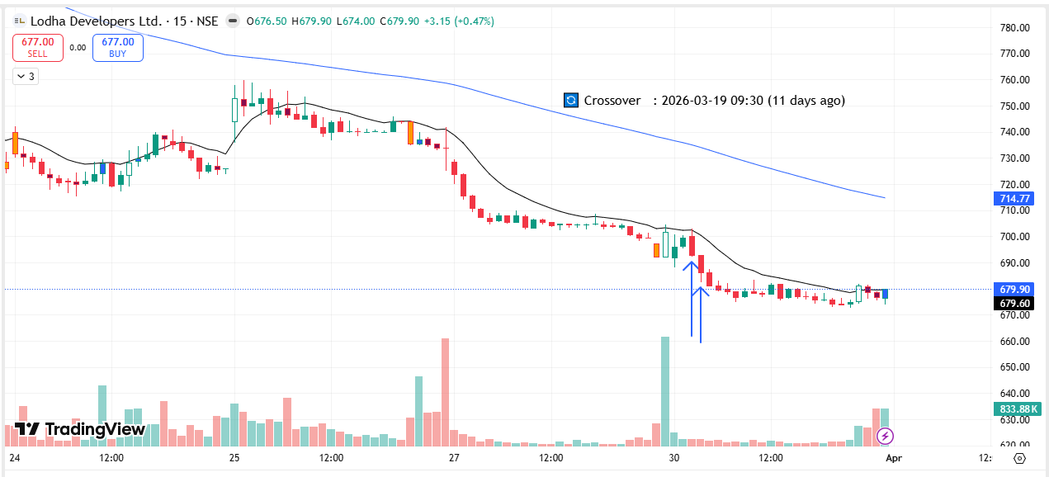
🔴 BEARISH SIGNAL --- LUPIN26AprFUT

Nifty Bias : 🔴 SHORT — Aligned ✅
Crossover : 2026-03-30 10:00 (a day ago)
Pullback : 2026-03-30 14:15
High ₹2329 ≥ EMA9(High) ₹2325.94
Low ₹2319.3 (breakdown level)
Confirm : 2026-03-30 14:45 (+2 candle)

🔴 BEARISH SIGNAL --- M&M26AprFUT

Nifty Bias : 🔴 SHORT — Aligned ✅
Crossover : 2026-03-27 12:00 (4 days ago)
Pullback : 2026-03-30 14:00
High ₹3008.8 ≥ EMA9(High) ₹3000.76
Low ₹2990.4 (breakdown level)
Confirm : 2026-03-30 14:30 (+2 candle)

🔴 BEARISH SIGNAL --- MANAPPURAM26AprFUT

Nifty Bias : 🔴 SHORT — Aligned ✅
Crossover : 2026-03-27 10:45 (4 days ago)
Pullback : 2026-03-30 13:30
High ₹254 ≥ EMA9(High) ₹253.6
Low ₹252.85 (breakdown level)
Confirm : 2026-03-30 13:45 (+1 candle)
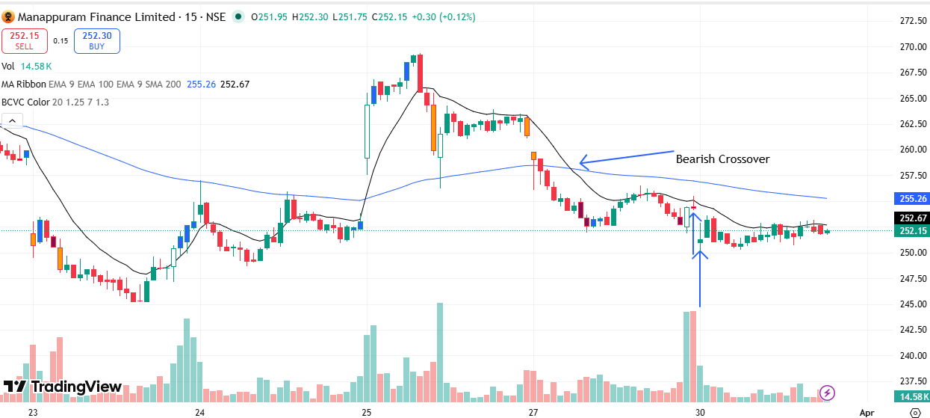
🔴 BEARISH SIGNAL --- MANKIND26AprFUT

Nifty Bias : 🔴 SHORT — Aligned ✅
Crossover : 2026-03-30 11:15 (a day ago)
Pullback : 2026-03-30 14:45
High ₹2011.1 ≥ EMA9(High) ₹2011
Low ₹2004.8 (breakdown level)
Confirm : 2026-03-30 15:00 (+1 candle)

🔴 BEARISH SIGNAL --- MARICO26AprFUT

Nifty Bias : 🔴 SHORT — Aligned ✅
Crossover : 2026-03-30 10:00 (a day ago)
Pullback : 2026-03-30 14:00
High ₹747.05 ≥ EMA9(High) ₹746.26
Low ₹743.3 (breakdown level)
Confirm : 2026-03-30 14:30 (+2 candle)

🔴 BEARISH SIGNAL --- MARUTI26AprFUT

Nifty Bias : 🔴 SHORT — Aligned ✅
Crossover : 2026-03-27 10:15 (4 days ago)
Pullback : 2026-03-30 14:00
High ₹12442 ≥ EMA9(High) ₹12435.18
Low ₹12387 (breakdown level)
Confirm : 2026-03-30 14:30 (+2 candle)
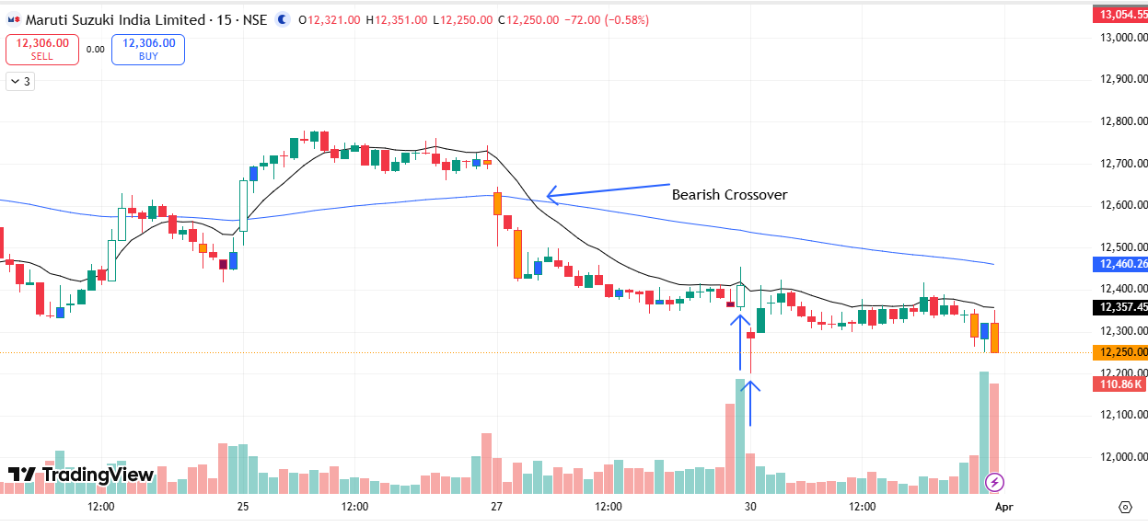
🔴 BEARISH SIGNAL --- MFSL26AprFUT

Nifty Bias : 🔴 SHORT — Aligned ✅
Crossover : 2026-03-25 15:00 (6 days ago)
Pullback : 2026-03-27 14:45
High ₹1572.8 ≥ EMA9(High) ₹1568.58
Low ₹1565.9 (breakdown level)
Confirm : 2026-03-27 15:00 (+1 candle)
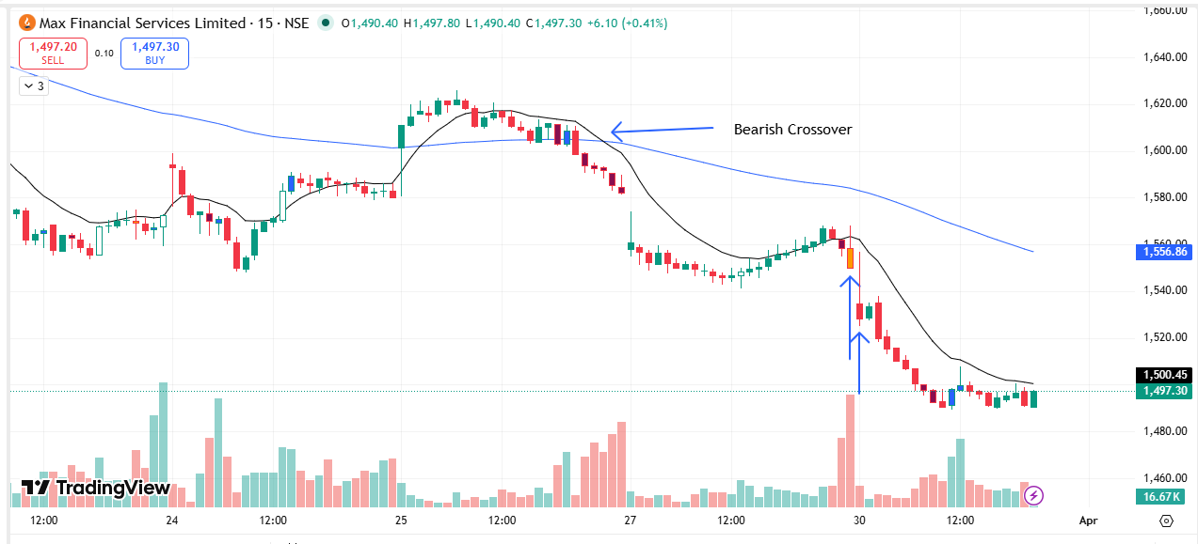
🔴 BEARISH SIGNAL --- MAXHEALTH26AprFUT

Nifty Bias : 🔴 SHORT — Aligned ✅
Crossover : 2026-03-30 09:30 (a day ago)
Pullback : 2026-03-30 14:45
High ₹968.6 ≥ EMA9(High) ₹968.24
Low ₹966.1 (breakdown level)
Confirm : 2026-03-30 15:00 (+1 candle)

🔴 BEARISH SIGNAL --- MAZDOCK26AprFUT

Nifty Bias : 🔴 SHORT — Aligned ✅
Crossover : 2026-03-25 13:00 (6 days ago)
Pullback : 2026-03-30 09:30
High ₹2195 ≥ EMA9(High) ₹2190.1
Low ₹2165.3 (breakdown level)
Confirm : 2026-03-30 09:45 (+1 candle)
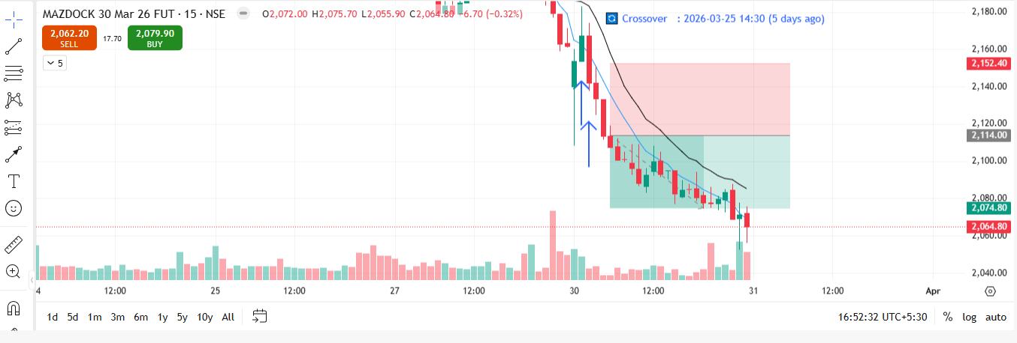
🔴 BEARISH SIGNAL --- MCX26AprFUT

Nifty Bias : 🔴 SHORT — Aligned ✅
Crossover : 2026-03-27 12:15 (4 days ago)
Pullback : 2026-03-30 14:30
High ₹2416.9 ≥ EMA9(High) ₹2416.77
Low ₹2408.5 (breakdown level)
Confirm : 2026-03-30 14:45 (+1 candle)

🔴 BEARISH SIGNAL --- MUTHOOTFIN26AprFUT

Nifty Bias : 🔴 SHORT — Aligned ✅
Crossover : 2026-03-30 11:45 (a day ago)
Pullback : 2026-03-30 14:00
High ₹3195 ≥ EMA9(High) ₹3191.08
Low ₹3175.1 (breakdown level)
Confirm : 2026-03-30 14:30 (+2 candle)

🔴 BEARISH SIGNAL --- NBCC26AprFUT

Nifty Bias : 🔴 SHORT — Aligned ✅
Crossover : 2026-03-27 10:30 (4 days ago)
Pullback : 2026-03-30 09:45
High ₹81.09 ≥ EMA9(High) ₹81.01
Low ₹80.37 (breakdown level)
Confirm : 2026-03-30 10:00 (+1 candle)
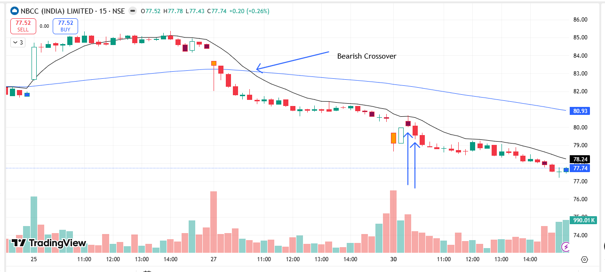
🔴 BEARISH SIGNAL --- NTPC26AprFUT

Nifty Bias : 🔴 SHORT — Aligned ✅
Crossover : 2026-03-30 09:30 (a day ago)
Pullback : 2026-03-30 12:15
High ₹377.3 ≥ EMA9(High) ₹377.15
Low ₹375.9 (breakdown level)
Confirm : 2026-03-30 12:45 (+2 candle)

🟢 BULLISH SIGNAL --- ONGC26AprFUT

Nifty Bias : 🔴 SHORT — Counter Trend ⚠️
Crossover : 2026-03-25 10:15 (6 days ago)
Pullback : 2026-03-30 15:00
Low ₹283.8 ≤ EMA9(Low) ₹284.9
High ₹285.1 (breakout level)
Confirm : 2026-03-30 15:15 (+1 candle)
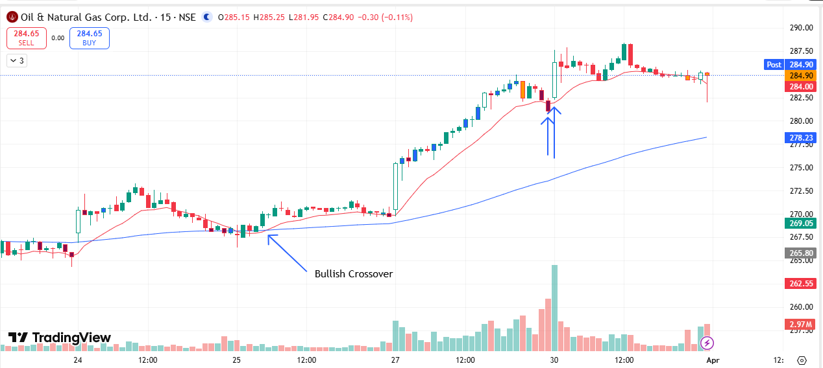
🔴 BEARISH SIGNAL --- POLICYBZR26AprFUT

Nifty Bias : 🔴 SHORT — Aligned ✅
Crossover : 2026-03-30 09:30 (a day ago)
Pullback : 2026-03-30 14:45
High ₹1436.9 ≥ EMA9(High) ₹1436.72
Low ₹1432.4 (breakdown level)
Confirm : 2026-03-30 15:00 (+1 candle)

🔴 BEARISH SIGNAL --- PNBHOUSING26AprFUT

Nifty Bias : 🔴 SHORT — Aligned ✅
Crossover : 2026-03-30 09:30 (a day ago)
Pullback : 2026-03-30 12:30
High ₹777.95 ≥ EMA9(High) ₹777.44
Low ₹773.3 (breakdown level)
Confirm : 2026-03-30 13:00 (+2 candle)

📊 TRADING SUMMARY
━━ ALL TRADES (31-Mar) ━━━━━━━━━━━━━━━━━━━━
Total Signals | 100
Taken Trades | 00
Not Taken | 100
Balance | Rs. 1,09,75,128.40
Current Balance | Rs. 1,09,27,812.86

━━ TODAY'S LIVE TRADING (31-Mar) ━━━━━━━━━━━━━━━━━━━━
Total | 0
Completed | 00
Wins ✅ | 0
Losses ❌ | 0
Open ⏳ | 0
Win Rate | 0.0%
Net P/L | +Rs. 0.00 , +0.00 pts
Brokerage | Rs. 0.00
Taxes & Fees | Rs. 0.00

━━ ALL-TIME LIVE TRADING ━━━━━━━━━━━━━━━━━━━━
Completed | 27
Wins ✅ | 11
Losses ❌ | 16
Open ⏳ | 4
Win Rate | 40.7%
Net P/L | -Rs. 44,755.04 , -90,811.25 pts
Brokerage | Rs. 2080.00
Taxes & Fees | Rs. 8220.53

━━ TODAY'S BACKTEST (31-Mar) ━━━━━━━━━━━━━━━━━━━━
Signals Today | 0
Resolved | 0
TARGET HIT ✅ | 0
SL HIT ❌ | 0
Open ⏳ | 0
Win Rate | 0.0%
Total PnL | +0.00 pts

━━ ALL-TIME BACKTEST SUMMARY ━━━━━━━━━━━━━━━━━━━━
Total Signals | 433
TARGET HIT ✅ | 214
SL HIT ❌ | 196
Open ⏳ | 23
Win Rate | 52.2%
Total PnL | +1,059.41 pts

🤖 TRADE BEHAVIOUR ANALYSIS
⛔ Trades Not Taken (100 signals skipped):
Counter-trend to Nifty bias — skipped (3): ASTRAL26AprFUT, DMART26AprFUT, ONGC26AprFUT
Aligned but not entered (97): 360ONE26AprFUT, ABB26AprFUT, APLAPOLLO26AprFUT, ADANIENSOL26AprFUT, ADANIENT26AprFUT, ADANIGREEN26AprFUT, ADANIPORTS26AprFUT, ABCAPITAL26AprFUT, ALKEM26AprFUT, AMBER26AprFUT, AMBUJACEM26AprFUT, ANGELONE26AprFUT, ASHOKLEY26AprFUT, BSE26AprFUT, BAJAJ-AUTO26AprFUT, BAJFINANCE26AprFUT, BAJAJFINSV26AprFUT, BANDHANBNK26AprFUT, BANKINDIA26AprFUT, BEL26AprFUT, BHARATFORG26AprFUT, BHEL26AprFUT, BIOCON26AprFUT, BLUESTARCO26AprFUT, BOSCHLTD26AprFUT, BRITANNIA26AprFUT, CGPOWER26AprFUT, CANBK26AprFUT, CDSL26AprFUT, CHOLAFIN26AprFUT, CIPLA26AprFUT, COFORGE26AprFUT, COLPAL26AprFUT, CAMS26AprFUT, CONCOR26AprFUT, CROMPTON26AprFUT, CUMMINSIND26AprFUT, DLF26AprFUT, DABUR26AprFUT, DELHIVERY26AprFUT, DIVISLAB26AprFUT, DIXON26AprFUT, DRREDDY26AprFUT, ETERNAL26AprFUT, EICHERMOT26AprFUT, FORTIS26AprFUT, GODREJCP26AprFUT, GODREJPROP26AprFUT, GRASIM26AprFUT, HCLTECH26AprFUT, HDFCAMC26AprFUT, HDFCBANK26AprFUT, HDFCLIFE26AprFUT, HAVELLS26AprFUT, HEROMOTOCO26AprFUT, HAL26AprFUT, HINDZINC26AprFUT, POWERINDIA26AprFUT, HUDCO26AprFUT, ICICIBANK26AprFUT, ICICIPRULI26AprFUT, IDFCFIRSTB26AprFUT, ITC26AprFUT, INDIANB26AprFUT, INDUSTOWER26AprFUT, INDUSINDBK26AprFUT, NAUKRI26AprFUT, INOXWIND26AprFUT, INDIGO26AprFUT, JINDALSTEL26AprFUT, JSWENERGY26AprFUT, JSWSTEEL26AprFUT, JIOFIN26AprFUT, JUBLFOOD26AprFUT, KEI26AprFUT, KFINTECH26AprFUT, KOTAKBANK26AprFUT, LTF26AprFUT, LTM26AprFUT, LT26AprFUT, LICI26AprFUT, LODHA26AprFUT, LUPIN26AprFUT, M&M26AprFUT, MANAPPURAM26AprFUT, MANKIND26AprFUT, MARICO26AprFUT, MARUTI26AprFUT, MFSL26AprFUT, MAXHEALTH26AprFUT, MAZDOCK26AprFUT, MCX26AprFUT, MUTHOOTFIN26AprFUT, NBCC26AprFUT, NTPC26AprFUT, POLICYBZR26AprFUT, PNBHOUSING26AprFUT
📝 100% of today's signals were not acted on. 3 were counter-trend — correct discipline to avoid. 97 aligned signals were not taken — review if entry was missed or risk was too high.

